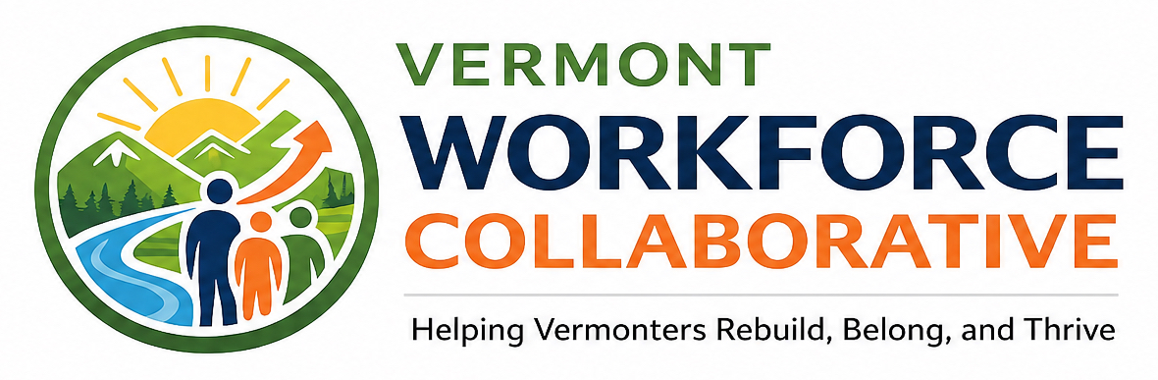
OUR MISSION
Building pathways to employment, stability, and opportunity across Vermont
Vermont Workforce Collaborative strengthens pathways to employment, stability, and opportunity for Vermonters facing barriers to work. Through workforce development, resource navigation, practical barrier-reduction support, and community-based collaboration, we help individuals build realistic and sustainable paths toward meaningful employment, training, and long-term success.
Who We Serve
We serve youth and adults impacted by the justice system, individuals returning from incarceration, people in recovery, and Vermonters navigating challenges related to mental health, poverty, transportation, housing, rural isolation, and limited access to support. Our work recognizes that employment barriers rarely exist on their own - and that finding a job is only one part of building lasting stability.
What We Believe
We believe people deserve to be seen for their strengths, potential, and capacity to grow - not defined solely by a background check, a period of instability, or the most difficult chapter of their lives.
Accountability and opportunity can exist together. Individuals can take responsibility for their past while still receiving the support, encouragement, and practical resources needed to move forward. Our work is grounded in second chances, empowerment, community, and meaningful follow-through.
ACCOUNTABILITY  Clear expectations, honest relationships, and meaningful follow-through. | SECOND CHANCES  Real opportunities to rebuild, contribute, and thrive. | COMMUNITY  Lasting solutions built through partnership and shared responsibility. | EMPOWERMENT  Tools, support, and confidence to shape a stronger future.

How We Carry Out Our Mission
Vermont Workforce Collaborative works alongside participants to understand their individual goals, strengths, support systems, and barriers. Instead of asking only whether someone is ready for a job, we ask what would make employment, stability, and long-term success possible.
● Individualized employment and career planning
● Connections to education, training, certifications, and apprenticeships
● Resource navigation and trusted community-based referrals
● Assistance addressing transportation, identification, clothing, tools, childcare, and other practical barriers
● Support building confidence, self-advocacy, readiness, and employment stability
● Partnerships that connect participants with meaningful and fair-chance opportunities
We also bring together employers, community organizations, courts, reentry programs, educators, funders, and people with lived experience. By strengthening these connections, we help bridge the space between individuals seeking an opportunity and the resources, relationships, and workplaces that can help make that opportunity sustainable.
“We do not just ask whether someone is ready for a job.
We ask what would make employment, stability, and long-term success possible.”
That question changes the work.
Our Vision
We envision a Vermont where every person has a meaningful opportunity to rebuild, contribute, and belong - regardless of the barriers they have faced or the path that brought them here.
Our mission is not simply to help people find jobs. It is to help Vermonters build the stability, connection, confidence, and opportunity they need to thrive.
HELPING VERMONTERS REBUILD, BELONG, AND THRIVE.

