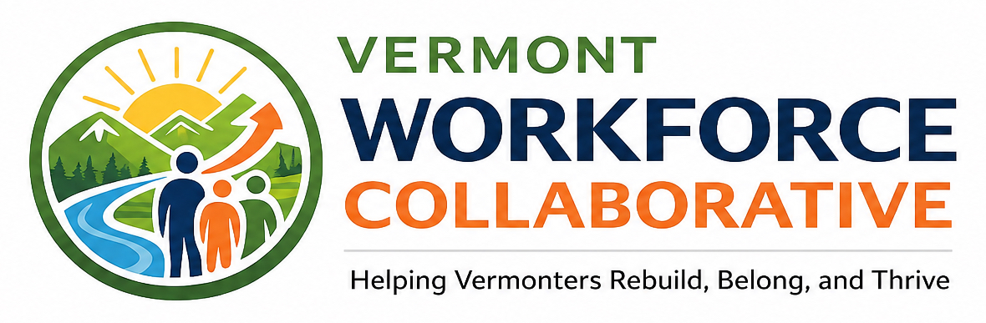
REENTRY TO WORKFORCE PILOT
From Reentry to Opportunity.
Stabilize. Prepare. Connect.
The Reentry to Workforce Pilot is Vermont Workforce Collaborative's first direct-service initiative. It will support justice-involved youth and adults as they build practical, individualized pathways toward employment, training, stability, and long-term success.
Launching in Orleans, Essex, and Caledonia counties, the pilot will begin with a small cohort so each participant can receive focused support and the organization can build a thoughtful model for future growth.

Pilot at a Glance
LAUNCH REGION  Orleans, Essex, and Caledonia counties | INITIAL COHORT  Approximately 5-10 participants | PARTICIPANT COST  No cost to participants | INITIAL ACCESS  Invitation-based partner referrals
Why This Pilot Matters
For many people impacted by the justice system, employment can be a turning point - but getting hired is only one part of the process. Long-term success often depends on whether someone has transportation, identification documents, stable housing, recovery or mental health support, appropriate work clothing, confidence, accountability, encouragement, and a realistic plan.
The Reentry to Workforce Pilot is designed to meet people in that space. It does not push participants into employment before they are ready. Instead, it helps each person build a practical pathway based on their strengths, needs, goals, and readiness.

Who the Pilot Will Serve
The pilot will support justice-involved Vermonters whose path to employment or training is affected by reentry, instability, or limited access to practical resources and support.
YOUTH AND YOUNG ADULTS  Ages 16-24 who are justice-involved or at risk of justice involvement. | ADULTS REENTERING  Adults returning from incarceration or navigating ongoing justice involvement. | PEOPLE FACING BARRIERS  Individuals affected by transportation, housing, mental health, recovery, poverty, rural isolation, or limited support.
How Participants Enter the Pilot
During the launch stage, participants will be identified through trusted community and justice-system partners. Beginning with an invitation-based referral model will allow the pilot to coordinate services carefully, establish clear communication, and provide meaningful follow-through.
Probation and Parole | Courts | Reentry Programs | Community Nonprofits
As the organization grows and builds capacity, Vermont Workforce Collaborative intends to expand access to include both partner referrals and self-referrals.
A Whole-Person Approach
The pilot begins by looking beyond a resume or background check. Each participant is supported in identifying their strengths, goals, immediate needs, and the real-life conditions that may affect whether employment can be accessed and sustained.
The goal is not quick placement. The goal is lasting progress toward work, stability, community connection, and opportunity.

The Participant Journey
1  STABILIZE  Identify immediate barriers and build a foundation. | › | 2  PREPARE  Build readiness for work, training, or education. | › | 3  CONNECT  Move toward meaningful next steps with ongoing support.

The Pilot Model
The Reentry to Workforce Pilot is organized around three connected phases. Participants may move through the phases at different speeds, and support will be tailored to individual readiness and goals.
1  STABILIZE | Participants begin by identifying immediate barriers that may affect employment, training, or long-term stability.  • Resource navigation and coordinated referrals  • Support obtaining identification documents  • Transportation assistance, as funding allows  • Connections to housing, recovery, mental health, and community resources  • Identification of short-term needs and long-term goals

2  PREPARE | Participants receive individualized support to build readiness for work, training, education, or another meaningful next step.  • One-on-one employment and career planning  • Resume, application, and interview preparation  • Confidence-building and self-advocacy support  • Career readiness and workplace expectations  • Connections to training, certifications, education, or apprenticeships

3  CONNECT | Participants are supported as they pursue employment, training, or education and begin building longer-term stability.  • Connections to employment and training opportunities  • Support communicating strengths, goals, and readiness  • Work-related barrier reduction  • Ongoing check-ins focused on employment stability  • Continued connection to community-based supports

Practical Barrier-Reduction Support
As funding allows, the pilot may help address specific, solvable barriers that prevent a participant from moving forward.
• Transportation or gas cards  • Identification documents  • Work or interview clothing  • Application or background-check fees | • Tools or work equipment  • Training or certification costs  • Childcare-related needs  • Phone, internet, or other work-related essentials

What Success Looks Like
Vermont Workforce Collaborative will track outcomes that reflect both employment progress and the stability needed to sustain it. Success will be measured through meaningful steps forward, not only through immediate job placement.
✓ Employment obtained | ✓ Employment retained for 30, 60, or 90 days
✓ Enrollment in training, education, certification, or apprenticeship opportunities | ✓ Identification documents or work-related supports obtained
✓ Transportation, clothing, tools, or other barriers addressed | ✓ Connections to recovery, housing, mental health, or community resources
✓ Increased confidence, readiness, and self-advocacy | ✓ Longer-term indicators of community stability and reduced justice-system involvement, where feasible
Long-Term Goal
The goal of the Reentry to Workforce Pilot is to test and strengthen a practical model for supporting justice-involved Vermonters in rural communities.
Through the initial cohort, Vermont Workforce Collaborative will learn what works, identify service gaps, strengthen referral partnerships, and build a foundation for expanding reentry employment support across Vermont over time.

Built Through Partnership
Sustainable reentry pathways require collaboration. Vermont Workforce Collaborative will work alongside probation and parole, courts, reentry organizations, community nonprofits, employers, educators, funders, and people with lived experience to create coordinated pathways that balance accountability with opportunity.
“We are not simply helping people find jobs. We are helping Vermonters rebuild, belong, contribute, and thrive.”
Helping Vermonters Rebuild, Belong, and Thrive
LEARN MORE, REFER A PARTICIPANT, OR EXPLORE PARTNERSHIP OPPORTUNITIES
VTworkforcecollaborative@outlook.com | (802) 624-0164

